FLOWISE
SOLUTION FOR DETECTING AND PREVENTING WATER LEAKS IN PAKISTAN’S URBAN INFRASTRUCTURE


Sara Khan 2949
Batool Tariq 2929

Supervised By
Ms. Quratulain Raja

Submitted for the partial fulfillment of the BS Computer Science degree to the Faculty of Engineering & CS

DEPARTMENT OF COMPUTER SCIENCE
NATIONAL UNIVERSITY OF MODERN LANGUAGES ISLAMABAD
January,2026

TABLE OF CONTENTS

Chapter 1 5
1.1 Project Domain 6
1.2 Problem Identification 6
1.2.1 Proposed Solution 6
1.2.2 Objectives 7
1.2.3 Scope of the Project 7
1.3 Effectiveness / Usefulness of the System 7
1.4 Resource Requirement 7
1.4.1 Hardware Requirement 7
1.4.2 Software Requirement 8
1.4.3 Data Requirement 8
1.5 Report Organization 9
Chapter 2 10
2.1 Related Literature Review 11
2.2 Related Systems/Applications 13
2.3 Identified Problem from Existing Work 15

Chapter 3 17
3.1 Interface Requirements 18
3.1.1 Hardware Interface Requirements 18
3.1.2 Software Interface Requirements 18
3.1.3 Tools and Technologies 19
3.2 Functional Requirements 20
3.3 Non-Functional Requirements 21
3.4 Resource Requirements 22
3.5 Project Feasibility 22
3.6 Summary 24
Chapter 4 25
4.1 System design and Analysis 26
4.2 Use Case Diagrams 27
4.3 Full Dress Use Case/Detailed Use Case 29
4.3.1 Leak Detection and Notification-Full Dress Use case 30
4.4 Activity Diagram 32
4.5 Data Flow Diagram 34
4.6 System Sequence Diagram 36
4.7 Sequence Diagram 37
4.8 Design Class Diagram 39
4.9 Architectural Diagrams 40
4.9.1Component Level Diagrams 41
References 43

Abstract
Pakistan faces a critical water shortage, with less water available per person due to low rainfall and 30-40% water loss from leaking pipelines. This issue, worsened by unaware citizens overusing water and outdated pipelines, pushes families to rely on costly water tankers, spending much of their income just to survive. Contaminated water also causes health problems, like waterborne diseases. Existing reactive methods to deal these pipeline leakages have proven inefficient as leaks go unnoticed for longer periods of time, resulting in more water lost. FlowWise seeks to save water and encourage smarter use by constantly monitoring pipelines. Our goal is to reduce non-revenue water and help people use water responsibly to ease the crisis.
Our IoT-based FlowWise system uses flow, pressure, and quality sensors placed along pipelines to gather real-time data, sent via ESP32 microcontrollers to cloud storage. Advanced AI models, LSTM and Random Forest, detect leaks accurately and alert officials through a mobile app with simple dashboards for both residents and authorities.By detecting leaks real-time and tracking household water use, FlowWise saves water, lowers costs, and builds awareness. Future versions will improve leak detection and expand to more cities, supporting sustainable water management in Pakistan.
Keywords
Water Scarcity, Pipeline leakages, Pakistan Pipelines, Leakage detection, Machine Learning, Internet of Things, Artificial Intelligence.

Chapter 1

INTRODUCTION

There is a serious water shortage in Pakistan right now. The amount of water available per person has drastically decreased from about 5,000 cubic meters in 1951 to about 1,000 cubic meters now [3]. Population increase, climate change, and—most importantly—outdated infrastructure are the main causes of this reduction. In cities like Karachi and Lahore, where 30–40% of the total water supply is lost as Non-Revenue Water (NRW), leaking pipes are a major cause [6].
Leaks are difficult for authorities to fix, which frequently causes supply disruptions for extended periods of time. The seriousness of this problem is demonstrated by recent events, such as the 400 million gallons of water lost in April 2025 due to a pipeline rupture in Karachi [7]. The existing reactive methods are unsustainable since leaks go undiscovered for days.
FlowWise aims to replace human, reactive inspections in water management with automated, real-time monitoring. This project intends to lower NRW and enable users to use water wisely by implementing an IoT-based system.

Project Domain
This project lies at the intersection of the Internet of Things (IoT) and Machine Learning (ML), specifically focusing on Time-Series Analysis for Smart Water Management. The system utilizes embedded hardware (ESP32 and YF-S201 Flow Sensors) for real-time data acquisition and employs the XGBoost algorithm to classify hydraulic states.

Problem Identification
Current manual methods in Pakistan are ineffective. Leaks go undiscovered for extended periods of time due to the lack of consolidated, real-time data. Furthermore, users are "blind" to their usage patterns, which leads to unintentional waste. The core problem is the inability of existing infrastructure to autonomously detect and mitigate flow anomalies in real-time.

Proposed Solution
FlowWise addresses these challenges using a hybrid IoT-ML approach. The system continuously monitors flow rates using Hall-effect sensors and transmits telemetry via an ESP32 to the cloud. An XGBoost (Extreme Gradient Boosting) model analyzes these flow patterns to detect leaks rapidly. Upon detection, the system triggers automated solenoid valves to minimize loss and alerts users via a mobile application.

Objectives
The primary objectives of the FlowWise project are:
- Develop an IoT-based data acquisition system using ESP32 and YF-S201 sensors.
- Train a Machine Learning model to classify system states ("Leak" vs. "Non-Leak") using time-series hydraulic data.
- Mitigate water loss through automated valve shutoff mechanisms.
- Visualize consumption trends and alerts via a user-friendly mobile dashboard.

Scope of the Project
Designed for Pakistan’s urban water infrastructure, this IoT-based solution offers a scalable model to reduce water wastage. The scope includes the development of a physical prototype (1–2-meter pipeline) equipped with flow sensors and automated valves to simulate urban distribution conditions. The system focuses specifically on flow anomaly detection. It is designed to function within a localized network but is scalable to larger smart city grids. The scope also covers the software implementation of cloud-based analytics and a mobile application for end-user engagement.

Effectiveness / Usefulness of the System
By guaranteeing that more water reaches users and lowering financial losses related to water tankers, FlowWise offers substantial utility.By detecting leaks in real-time, the device reduces water loss and does away with the need for laborious human inspections. By providing clients with information about their daily usage, a consumer dashboard encourages responsible consumption. Additionally, by updating outdated infrastructure and promoting innovation through cutting-edge technologies, the system supports SDGs 6 (Clean Water and Sanitation) and 11 (Sustainable Cities and Communities).

Resource Requirement

Hardware Requirement
The development and execution of the system require specific IoT components.
- Microcontroller: An ESP32 Development Board is used as the central processing unit to read sensor data and transmit it via Wi-Fi.
- Sensors: Two YF-S201 Hall-effect water flow sensors are employed to measure the flow rate at the inlet and outlet of the pipeline section.
- Leak Simulation: A Manual Ball Valve connected via a PVC T-joint is installed between the two sensors. Opening this valve physically diverts water, simulating a burst pipe or leakage scenario for testing.
- Pipeline Prototype: A 1–2-meter PVC piping setup serves as the physical testbed for mounting sensors and simulating hydraulic dynamics.

Software Requirement
- IoT Cloud Platform: Arduino IoT Cloud is used for device management and ensuring stable ESP32 connectivity.
- Backend & Database: Firebase Realtime Database stores live sensor telemetry, while Firebase Authentication manages secure, role-based access for Admins and Users.
- Mobile Application: Flutter (via Android Studio) is used to develop the cross-platform mobile app for real-time monitoring and consumption analytics.
- Machine Learning Environment: Python 3.x (with Pandas & NumPy) functions as the inference engine for feature engineering and real-time processing.
- Modeling Libraries: XGBoost is required for the leak detection classifier, validated using Scikit-learn.
- Firmware Development: Arduino IDE (C++) is used to program the ESP32 microcontroller.

Data Requirement
To ensure the Machine Learning model is both accurate and adaptable to different network topologies, a multi-stage data strategy is employed, consisting of benchmark training data, simulated validation data, and physical calibration data.
- Primary Training Dataset (LeakDB): The core training of the XGBoost Classifier relies on LeakDB, a large-scale standardized dataset generated from EPANET hydraulic simulations. This data set provides a diverse range of realistic leak scenarios, varying pressure conditions, and background noise profiles. Using LeakDB ensures the model learns fundamental hydraulic anomaly patterns on a complex network structure before being introduced to specific hardware.
- Validation Dataset (Simulated Hydraulic Model): To verify the network independency of the model (i.e., its ability to detect leaks on a network it was not trained on), a custom Hydraulic Model was created to digitally replicate the topology of the proposed hardware prototype (a 1–2-meter pipeline section). A synthetic dataset was generated from this custom model to test the LeakDB-trained classifier. This step serves as a critical validation checkpoint to confirm that the model generalizes well to new pipe configurations before physical deployment.
- Physical Prototype Dataset (Fine-Tuning): Following successful simulation validation, a real-world dataset is collected from the physical testbed using the YF-S201 Flow Sensors. This data captures hardware-specific characteristics, including sensor noise, signal drift, and environmental fluctuations (which simulations often miss). This dataset is used to fine-tune the model, ensuring high precision when running on the ESP32 and Python Inference Engine.

Report Organization
The report is organized into six chapters.
- Chapter 1 introduces the project, its objectives, and scope.
- Chapter 2 provides a background study and literature review of existing leak detection systems.
- Chapter 3 details the system requirements and specifications, including functional and non-functional requirements.
- Chapter 4 covers the system modeling and design, presenting architectural diagrams.
- Chapter 5 discusses the system testing, validation, and experimental results of the XGBoost model.
- Chapter 6 concludes the report and outlines future enhancements.

Chapter 2

BACKGROUND AND EXISTING SYSTEMS

2: Background and Existing Wor
The proposed system, FlowWise, addresses the critical issue of water distribution inefficiency by employing an IoT-based monitoring framework and advanced Machine Learning techniques. By integrating YF-S201 flow sensors for real-time data acquisition and utilizing the LeakDB dataset for model training, the system aims to provide accurate leak detection and localization in water networks.
In this chapter, we have discussed the related systems and their applications along with their limitations. We first analyze the research methodologies and findings of existing literature, followed by a technical review of the hardware systems developed by these researchers. Finally, we identify the research gaps that define the scope of our proposed solution.

Related Literature Review
In this section, we discuss the research methodologies, hypotheses, and experimental findings of three significant papers relevant to our domain.
Ayamga and Nakpih (2024) presented a study on an IoT-based system named "iWaLDeL" for leak detection and localization. The authors utilized a static leak detection methodology, employing flow rate sensors to compare water pressure at different network nodes. Their findings demonstrated that leakages could be located mathematically by calculating the difference between sensor readings and the known distance between pipes. However, a significant limitation of this work is its reliance on a "Machine State Model", which is a rigid, rule-based logic (If-Then statements). This approach lacks the adaptive capability of Machine Learning, meaning it can only detect leaks that strictly violate pre-set thresholds and cannot learn from historical data patterns [1].
Gautam et al. (2020) focused on monitoring water consumption and forecasting demand in urban housing complexes. The authors proposed a methodology using Ultrasonic sensors to monitor rooftop tanks and applied Support Vector Machines (SVM) to forecast future water usage. Their experimental results showed that while SVM could accurately predict consumption trends, the leak detection aspect was rudimentary. The study assumes a leak only exists if the water level drops while the "InUse" flag is false. This limits the application strictly to storage tanks; it cannot detect leaks in the underground pipeline network where pressurized flow dynamics are different [4].
Boujelben et al. (2023) proposed an end-to-end system for leak detection and localization based on non-invasive acoustic sensing and lightweight Machine Learning. The authors developed a 1D-Convolutional Neural Network (1D-CNN) to classify raw audio signals collected from pipeline surfaces. Their methodology involved a dual-model approach: a classification model embedded on the edge node to detect leaks, and a regression model on the server to estimate the 2D position of the leak. The experimental findings demonstrated a leak detection accuracy of 97% and precise localization with a Mean Squared Error (MSE) of 0.0006 for the X-coordinate. However, a limitation of this acoustic approach is the inherent complexity of processing raw audio data, which requires significant computational resources compared to hydraulic data, and its susceptibility to external environmental noise in dense urban settings [2].

Table 2.1 Summary of Reviewed Literature
Year | Authors | Contribution | Techniques | Limitations
2023 | Boujelben et al. | Acoustic leak detection and 2D localization. | Acoustic Sensors, 1D-CNN (Machine Learning), Regression Model. | Acoustic processing is computationally heavy; sensitive to external environmental noise.
2024 | Ayamga & Nakpih | Pipeline leak detection and localization using flow comparison. | YF-S201 Sensors, Static Math Logic (No ML). | Relies on rigid Threshold-based logic; cannot learn new patterns; requires dense sensor placement.
2020 | Gautam et al. | Water consumption forecasting and tank level monitoring. | Ultrasonic Sensors, SVM (Support Vector Machine). | Focuses on tanks, not pipelines; Leak detection is rule-based (Level drop), not ML-based.

Related Systems/Applications
This section reviews the hardware configurations and system architectures of the discussed solutions, highlighting their operational capabilities and limitations.
Acoustic IoT Leak Detection System: The system prototype designed by Boujelben et al. is an acoustic monitoring node based on an Arduino microcontroller equipped with a microphone and a LoRa shield for long-range communication. A key feature of this system is the implementation of "Edge Computing," where the lightweight 1D-CNN classification model runs directly on the device to analyze raw audio signals. However, the engineering constraint lies in the nature of acoustic propagation; while these sensors are non-invasive (attached to the surface), they struggle to maintain accuracy on plastic (PVC) pipes where vibration signals attenuate rapidly compared to metal pipes. Furthermore, they are highly sensitive to environmental noise (e.g., traffic), requiring complex and computationally expensive filtering that is difficult to sustain on low-power battery devices [2].
iWaLDeL - IoT Water Leakage Detection System: The system developed by Ayamga and Nakpih is a hardware prototype featuring YF-S201 turbine flow sensors interfaced with an ESP32 microcontroller. Its primary functionality is to measure flow rates at fixed intervals (e.g., every 100m) and transmit data to an Arduino Cloud dashboard. While the system successfully visualizes real-time flow, its engineering constraint is the "Machine State Model" architecture. The system operates on a fixed loop (Idle → Comparison → Alarm), meaning it lacks an intelligent inference engine. It simply flags an alarm if Sensor A != Sensor B, which can lead to false positives due to sensor calibration drift or minor fluctuations [1].
Smart Water Management & Forecasting System: The application proposed by Gautam et al. is designed for residential water management. It utilizes HC-SR04 Ultrasonic sensors mounted on top of water tanks to measure the distance to the water surface. The system features a web interface that displays daily consumption and predicts future demand using SVM. However, from a technical standpoint, this is a Tank Monitoring System, not a distribution monitoring system. It relies on the water being static in a tank to detect leaks. It does not possess the hydraulic flow sensors necessary to monitor the dynamics of moving water in a pressurized pipeline network [4].

Table 2.2 Summary of Existing System
Year | System | Contribution | Tool/Technologies | Limitations | Applications
2023 | Acoustic IoT System | Intelligent Edge detection. | Arduino, Mic, LoRaWAN, 1D-CNN. | High hardware complexity: Acoustic sensors struggle in noisy urban areas. | Long-range pipeline networks.
2024 | iWaLDeL (Nakpih) | Pipeline monitoring & localization. | YF-S201 Flow Sensor, ESP32, Arduino Cloud. | Uses hard-coded logic (State Machine); no predictive ML capability. | Residential distribution.
2020 | Smart Water (Gautam) | Consumption forecasting. | Ultrasonic Sensor, SVM, Web Dashboard. | Limited to Rooftop Tanks; cannot detect pipeline bursts. | Urban housing, Tank management.

Identified Problem from Existing Work
In this section, we discuss and elaborate on the problems identified from the existing systems.
- Noise Sensitivity and Cost: While Boujelben et al. successfully applied Deep Learning, their reliance on acoustic/audio data makes the system expensive and vulnerable to environmental noise (traffic, construction), which is a major issue in urban Pakistan.
- Lack of Intelligence in Hydraulic Systems: Ayamga and Nakpih utilize the correct hardware (Flow Sensors) but rely on static programming. This approach fails to capture complex hydraulic patterns and is prone to errors if sensors are not perfectly calibrated.
- Wrong Domain Focus: Gautam et al. employ Machine Learning (SVM), but only for tanks. There is a lack of systems that apply Machine Learning specifically to detect leaks in flowing pipelines using hydraulic data.
To improve upon this, our proposed system (FlowWise) will bridge these gaps by combining the hydraulic flow sensor approach (like Nakpih) with Advanced Machine Learning (improving on Boujelben's CNN approach but for flow data), validated on the standardized LeakDB dataset.

Selected Boundary for Proposed Solution
- Functionalities to be Implemented: The proposed FlowWise system will focus on hydraulic leak detection in pipeline networks. We will implement a Machine Learning model using the XGBoost Classifier, trained on the LeakDB dataset, to identify non-linear leak patterns with high computational efficiency. This model will be integrated with a physical prototype using YF-S201 flow sensors and ESP32 microcontrollers to demonstrate real-time inference. This approach effectively replaces the expensive acoustic sensors of Boujelben et al. with cost-effective flow sensors, while upgrading the static logic of Ayamga & Nakpih to a dynamic, data-driven AI engine capable of adapting to complex flow variations.
- Functionalities Not to be Implemented: The system will not monitor water quality parameters (pH, turbidity) or utilize acoustic/vibration sensors, as these are outside the scope of hydraulic dynamics. Furthermore, unlike Gautam et al., we will not focus on rooftop tank level monitoring; our boundary is strictly the distribution pipeline network. While leak localization will be validated via simulation on the LeakDB dataset, physical localization on the hardware prototype will be limited due to the constraint of using a two-node sensor setup.

Chapter 3

SYSTEM REQUIREMENTS AND SPECIFICATIONS

- Chapter 3: System Requirements and Specifications

This chapter lays out the fundamental architecture of the FlowWise system, acting as a formal blueprint as well as a technical road map. These requirements guarantee that the system is not just a technical exercise but a workable solution for resource conservation in Pakistan, where local water scarcity is greatly exacerbated by aging infrastructure and Non-Revenue Water (NRW) loss. This chapter guarantees that the system satisfies the high stakes of actual water management by outlining the hardware, software, and functional parameters.

Interface Requirements

Hardware Interface Requirements
The physical layer must handle high-frequency data acquisition and local processing:
- Edge Processing Unit: The central controller must support high-speed processing and include expanded volatile memory (PSRAM) to facilitate on-device Machine Learning inference and concurrent data transmission.
- Sensing Layer: Flow sensors utilize Hall-effect technology to generate pulse signals. These signals are interfaced via digital Input/Output pins to calculate volumetric flow rates.
- Data Acquisition: The hardware must be capable of interrupt-driven counting in order to provide accurate data collection from multiple sensor nodes without lag.
- Training Environment: A high-performance workstation with sufficient memory and computational power is required for large-scale data analysis, hyperparameter tuning, and model validation before deployment to the edge.

Software Interface Requirements
From training and simulation to real-time anomaly detection, the software ecosystem oversees the data's lifecycle:
- Hydraulic Simulation: A specialized simulation library is used to create a digital twin of the water distribution network. This allows for the generation of synthetic data to enhance the diversity of the training samples and simulate various leak scenarios.
- Data Processing and Modeling: The system utilizes robust data manipulation libraries for time-series feature engineering and the development of gradient-boosted decision models optimized for anomaly detection.
- Edge Deployment Layer: To ensure minimal resource usage during inference, the trained predictive models must be translated into a low-level language that is compatible with the firmware of the edge controller.
- Embedded Firmware: The firmware manages safe data synchronization with the cloud backend, local model execution, and sensor pulse integration.
- Online and User Interface (UI) Requirements: The system ensures continuous connectivity between the physical infrastructure and the administrative staff:
- Cloud Data Synchronization: The central repository is a real-time NoSQL database. Over a wireless local area network (WLAN), the edge device transmits data packets containing anomaly flags and flow status.
- Mobile Management Application: The main user interface is a dashboard that is optimized for mobile devices and offers historical trends and real-time network health visualization.
- Automated Alerting System: When a possible breach is detected by the local model, the interface must provide push notifications in order to give administrators prompt, high-priority alerts.
- Network Diagnostics: The UI must display the operational status of all deployed hardware nodes to ensure the integrity of the monitoring network.

Tools and Technologies
The following technologies and frameworks are utilized to implement the functional requirements of the FlowWise system:
- ESP32-WROVER-E: A high-performance microcontroller featuring 8MB of external PSRAM and 16MB of Flash memory, selected to support on-device Machine Learning inference and robust Wi-Fi connectivity.
- YF-S201 Flow Sensor: A Hall-effect-based sensor used to measure water flow velocity by generating pulse signals, which are then processed by the microcontroller to calculate real-time volumetric data.
- XGBoost (Extreme Gradient Boosting): An optimized distributed gradient boosting library used to train the leak detection model, chosen for its high efficiency and accuracy with structured time-series data.
- WNTR (Water Network Tool for Resilience): An EPANET-compatible Python library used to simulate hydraulic behavior and generate synthetic datasets to supplement real-world sensor data.
- LeakDB Dataset: A comprehensive open-source library of simulated water distribution leaks used as the primary training foundation for the anomaly detection model.
- Firebase Realtime Database: A cloud-hosted NoSQL database used to synchronize data across the nodes and the mobile application with sub-second latency.
- Python (Pandas & NumPy): The core programming language and libraries used for high-level data manipulation, feature engineering, and training the predictive model on Kaggle's high-memory environments.
- M2cgen (Model to Code Generator): A tool used to transpile the trained XGBoost model into pure C code, allowing the algorithm to run natively on the ESP32 hardware without a Python interpreter.
- Arduino IDE / PlatformIO: The integrated development environments used for writing and uploading the C++ firmware that manages sensor interrupts and cloud communication.

Functional Requirements
The FlowWise system is partitioned into autonomous modules that act as active agents within the network.
- Leak Detection Intelligence Module
This agent continuously evaluates inlet and outlet flow differentials. It is trained to autonomously distinguish between "Demand Surges" (normal use) and "Structural Failures" (leaks) by analyzing temporal windows. The logic is executed locally at the edge to ensure immediate detection.

- IoT Data Acquisition Module
This module acts as the "sensory system" of the network. It manages the low-level hardware interruptions required to convert raw pulse signals from the hardware sensors into calibrated volumetric flow data (Liters/Minute).
- Spatial Localization Module
This module is responsible for pinpointing the physical coordinates or the specific pipe segment where a failure has occurred. While the current hardware prototype utilizes a simplified two-node setup, this module validates the system's scalability.
- Consumer Usage
This module provides a dedicated interface for the end-user. It aggregates individual consumption data over time, allowing consumers to track their hourly, daily, and monthly water usage. By providing transparency into consumption habits, this module encourages water conservation.
- Analytics and Notification Module
The module visualizes live flow rates across the system, allowing the admin to monitor consumption trends and peak demand periods in specific geographical areas. When an anomaly is identified as a "Leak," the agent triggers a high-priority push notification.

Non-Functional Requirements
- Classification Precision: The system must maintain high accuracy for both "Leak" and "No-Leak" states to eliminate false positives. This prevents "Alert Fatigue" by ensuring the model can distinguish between actual structural failures and normal diurnal demand fluctuations or sensor jitter.
- Temporal Context: To give the Machine Learning model enough historical background, a set 15-hour lookback window is necessary. Before a classification is created, this latency is crucial for removing fleeting noise and comprehending the 24-hour water usage cycle.
- Connectivity Resilience: In the event of a Wi-Fi or cloud failure, the system continues to monitor and log leak statuses locally, synchronizing with the database as soon as it reconnects. The edge node must support local autonomy.
- Scalable Architecture: The software logic, developed using specialized hydraulic simulation libraries, must be scalable from the current two-node hardware prototype to a complex, multi-junction urban distribution network without requiring a redesign of the core detection algorithm.

Resource Requirements
This section identifies the essential assets required to develop, train, and deploy the FlowWise system.
- Hardware Resources
ESP32-WROVER-E development boards, YF-S201 Hall-effect flow sensors, a 3.3V/5V power supply, and a high-performance workstation (minimum 12GB RAM) for model training.
- Software Resources
Python development environment, Machine Learning frameworks for model transpilation, and a mobile application development kit for the administrator dashboard.
- Data Resources
The LeakDB open-source dataset and a custom-generated synthetic dataset produced via WNTR hydraulic simulations.
- Network Resources
A stable 2.4GHz Wi-Fi infrastructure for data synchronization and cloud-based real-time database hosting.

Project Feasibility
The feasibility study evaluates the practical application of the monitoring system within the context of current technological constraints and regional infrastructure challenges.
- Technical Feasibility
The project’s technical viability is supported by the successful integration of hydraulic science and localized machine learning:
- Edge-Inference Capability: It is technically feasible to deploy complex analytical models directly onto high-performance microcontrollers. By utilizing expanded volatile memory and model-transpilation techniques, the system can perform real-time analysis locally, reducing the dependency on high-bandwidth cloud processing.
- Algorithmic Robustness: Time-series hydraulic data are a great fit for gradient-boosted decision models. By eliminating the "noise" of daily water demand, this method enables the system to precisely detect trends linked to structural breakdowns.
- Data Synergy: The research uses a hybrid data strategy, combining site-specific synthetic simulations with extensive open-source hydraulic information. This guarantees that the prediction models are appropriately adjusted to the physical dimensions of the local distribution network and have a comprehensive knowledge base.
- Operational Feasibility
This section examines the system's effectiveness in a real-world environment characterized by intermittent power and connectivity:
- Autonomous Operation: The system is designed to maintain detection logic at the hardware level. This ensures that the water network is monitored even during network outages. While notification delivery is dependent on active connectivity, the "intelligence" of the system remains operational within the physical infrastructure.
- Administrative Oversight: A centralized perspective of network health is offered by the mobile-first dashboard design. Utility administrators may react to outages within hours rather than days thanks to the system's ability to convert raw flow data into meaningful insights through real-time data synchronization and automated alerting.
- Resource Management: By offering individual usage metrics, the system generates operational value for the supplier and the customer, enabling more precise billing and promoting water conservation at the home level.
- Legal and Ethical Feasibility
- Public and Structural Safety: From an ethical perspective, the system offers a crucial service by spotting leaks that can cause serious structural harm, including foundation weakness or soil erosion. The community directly benefits from this in terms of safety.
- Environmental Sustainability: The initiative supports national water security objectives. The method facilitates the sustainable management of a limited and vital natural resource by drastically lowering "Non-Revenue Water" (NRW) through quick leak identification.

Summary
This chapter has detailed the essential requirements that define FlowWise. By focusing on modular intelligence and rigorous interface specifications, we have created a roadmap that ensures the system can effectively combat water loss while remaining user-friendly and technically robust.

Chapter 4

SYSTEM MODELING AND DESIGN

The design and modeling phase serves as a critical bridge between system requirements and actual implementation, transforming abstract specifications into concrete architectural blueprints. In the context of FlowWise, an IoT-based water leakage detection system for Pakistan's urban pipeline infrastructure, comprehensive system modeling ensures that hardware components, software modules, and data flows are properly orchestrated to achieve the project objectives. This phase involves creating various diagrams and models that capture both the structural and behavioral aspects of the system, to visualize system operations before committing resources to development.
System modeling provides multiple benefits for complex IoT systems like FlowWise. It facilitates communication among team members by providing standardized visual representations of system architecture. It helps identify potential design flaws early in the development cycle when changes are less costly to implement. Additionally, well-documented models serve as reference materials throughout the implementation and maintenance phases, ensuring consistency and reducing the likelihood of errors during coding and deployment.
This chapter presents the detailed design and analysis models for the FlowWise system. Section 4.1 provides an overview of the system design and analysis approach adopted for this project. Section 4.2 presents use case diagrams illustrating interactions between users and the system. Section 4.3 details full dress use cases for complex system operations. Section 4.4 presents activity diagrams showing workflow processes. Section 4.5 describes data flow diagrams at multiple abstraction levels. Section 4.6 illustrates system sequence diagrams for key scenarios. Section 4.7 presents detailed sequence diagrams showing component interactions. Section 4.8 shows the design class diagram representing the object-oriented structure of the system. Finally, Section 4.9 presents architectural diagrams including interface design, component level design, and deployment architecture.

System design and Analysis
The FlowWise system utilizes an edge-first architecture that processes machine learning algorithms directly on the ESP32-WROVER-E microcontroller. By deploying a lightweight, optimized XGBoost model, refined through quantization and pruning, the system achieves high-speed leak detection within milliseconds, bypassing the latency and costs of cloud-based processing. This localized intelligence ensures enhanced data privacy and operational reliability, as the system functions independently of network stability. While inference happens at the edge, a Cloud Storage Tier powered by Firebase Realtime Database handles historical data persistence, user profiles, and real-time synchronization with mobile applications via WebSockets.
This prototype implements the FlowWise architecture through a single ESP32-WROVER-E node monitoring two distinct pipe segments via dual flow sensors. Despite the smaller scale, the system maintains the dual-tier approach, balancing real-time responsiveness with cloud-based persistence: the ESP32 performs local inference to detect leaks across both pipes simultaneously, while the Firebase backend manages configuration and historical logging. The system is validated through a suite of analysis models: Activity and Data Flow modeling trace the dual-sensor input through the XGBoost algorithm, while Sequence and Use Case modeling ensure the prototype accurately alerts the user and stores consumption data for both monitored lines.

Use Case Diagrams
Use case diagrams provide a high-level functional view of the system by illustrating the interactions between actors and the system's use cases. For FlowWise, two primary actors have been identified based on their roles and responsibilities within the water distribution ecosystem. The Consumer actor represents individual water users or households connected to the monitored pipeline network. Consumers interact with the system primarily through mobile applications to track their personal water consumption and receive notifications about detected leaks that may affect their service. The Administrator actor represents personnel from water authorities responsible for managing and monitoring the entire water distribution infrastructure. Administrators have elevated privileges that allow them to view system-wide data, manage system configurations, and analyze leak patterns across the network.
The Consumer actor can perform several use cases within the FlowWise system. The View Personal Consumption Data use case allows consumers to access their water usage information organized by different time periods. This use case extends to View Hourly Usage, View Daily Usage, and View Monthly Usage, enabling consumers to analyze consumption patterns at various granularities. The View Consumption History and Trends use case provides historical data visualization, helping consumers identify unusual usage patterns or gradual changes in their consumption behavior. The Receive Leak Notifications use case ensures consumers are immediately informed when the ESP32 device detects potential leaks in their service area based on the on-device machine learning model, enabling prompt action to prevent water wastage and property damage.
The Administrator actor has access to broader system functionalities designed to support infrastructure management and decision making. The View All Consumers Data use case allows administrators to access aggregated consumption information across all users in the network, facilitating load balancing and capacity planning. The Monitor Real-time Flow Analytics use case provides live dashboards showing current flow rates at all sensor nodes, system health metrics, and consumption trends across different geographical areas or time periods. The Receive Leak Notifications use case functions similarly for administrators as it does for consumers, but administrators receive notifications for all detected leaks system-wide rather than just those affecting a specific location. The Generate System Reports use case enables administrators to create comprehensive reports summarizing system performance, water loss statistics, and consumption patterns over specified time periods. The Configure System Parameters use case allows administrators to remotely update detection thresholds, calibration factors, and notification settings on deployed ESP32 devices through Firebase.
The use case diagram shown in Figure 4.1 illustrates these relationships between actors and use cases. The diagram clearly delineates the system boundary, showing which functionalities belong to the FlowWise system and which actors operate external to it. Some use cases are exclusive to specific actors, while others like receiving leak notifications are shared between both actor types, though their implementation details may differ based on the actor's role. The diagram serves as a contract between stakeholders, ensuring mutual understanding of system capabilities and user expectations.
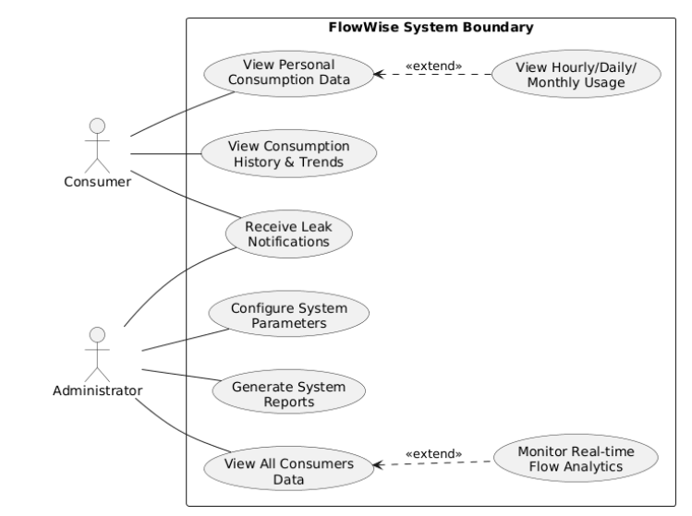
Figure 4.1 FlowWise System Boundary

Full Dress Use Case/Detailed Use Case
Full dress use cases provide comprehensive documentation of complex system operations by detailing all aspects of the interaction between actors and the system. These detailed specifications go beyond simple use case diagrams by documenting preconditions that must be satisfied before the use case can execute, success guarantees that define the system state after successful completion, main success scenarios that describe the typical flow of events, and extensions that handle alternative paths and error conditions. For FlowWise, several use cases warrant detailed documentation due to their complexity and criticality to system operations. This section presents full dress use cases for the most significant system operations.

Leak Detection and Notification-Full Dress Use case
The leak detection and notification process represents the core functionality of the FlowWise system, operating continuously on the ESP32 microcontroller to identify and report water leakage incidents. This use case is particularly complex as it involves automatic triggering without explicit user initiation, on-device machine learning inference, coordination between embedded firmware and cloud services, and time-critical notification delivery. The detailed specification in Table 4.1 provides a complete description of this critical use case including all normal and exceptional scenarios.
The use case begins automatically when the ESP32 microcontroller reads flow data from sensors positioned at two nodes in the pipeline. The embedded XGBoost model processes this data locally without requiring cloud connectivity, making leak detection decisions based on learned patterns. The system must ensure that both sensors are operational and providing valid readings before proceeding with analysis. The main success scenario describes the ideal path where flow data is successfully captured, the on-device machine learning model correctly classifies the flow pattern as either normal or leak condition, results are transmitted to Firebase for storage and audit purposes, and appropriate notifications are triggered when leaks are detected.
Extensions handle various exceptional conditions that may occur during the leak detection process. These include sensor malfunction scenarios where one or both flow sensors fail to provide valid readings, requiring the system to log the error locally and attempt to transmit an alert to administrators when connectivity is restored. WiFi connectivity problems may prevent the ESP32 from transmitting detection results to Firebase, necessitating local storage in flash memory until the connection is restored. Model inference failures due to corrupted model files or memory issues require fallback to simple threshold-based detection. Notification delivery failures must be detected through Firebase acknowledgments and retried to ensure critical leak alerts reach their intended recipients. Each extension specifies the system's response to these exceptional conditions, ensuring robust operation even when components fail or behave unexpectedly.

Table 4.1
Use Case Selection | Comment
Use Case Name | Detect Water Leakage Using Edge ML and Notify Users
Scope | FlowWise Water Leakage Detection System
Level | User Goal
Primary Actor | System (Automated Process on ESP32) Orchestrates sensor data collection and ML inference.
Stakeholder and Interests | Consumers, Administrators, and Water Authority: All seek to minimize water loss and optimize infrastructure efficiency through immediate leak alerts.
Pre-Conditions | Operational Readiness: Flow sensors (P1, P2) installed, XGBoost model loaded on ESP32, and Firebase/WiFi credentials configured.
Success Guarantee | End-to-End Notification: Classification results logged in Firebase and alerts delivered via Push/SMS within 15 seconds of detection.
Main Success Scenario | Detection Pipeline: ESP32 reads sensor data, engineers 6 features, executes XGBoost inference, and triggers Firebase Cloud Functions for user notification.
Extensions | Fail-safes: Includes fallback threshold detection for model failure, data buffering for WiFi outages, and multiple retries for notification delivery.
Special Requirements | Performance Standards: < 100ms inference time, < 4MB RAM usage, 99% uptime, and data encryption via TLS 1.2+.

Activity Diagram
Activity diagrams model the procedural flow of actions within a system, illustrating the sequence of activities, decision points, and concurrent processes. For the FlowWise system, this diagram models the critical edge-based leak detection and notification workflow, which coordinates hardware sensors, embedded ML, and cloud-based notification systems.
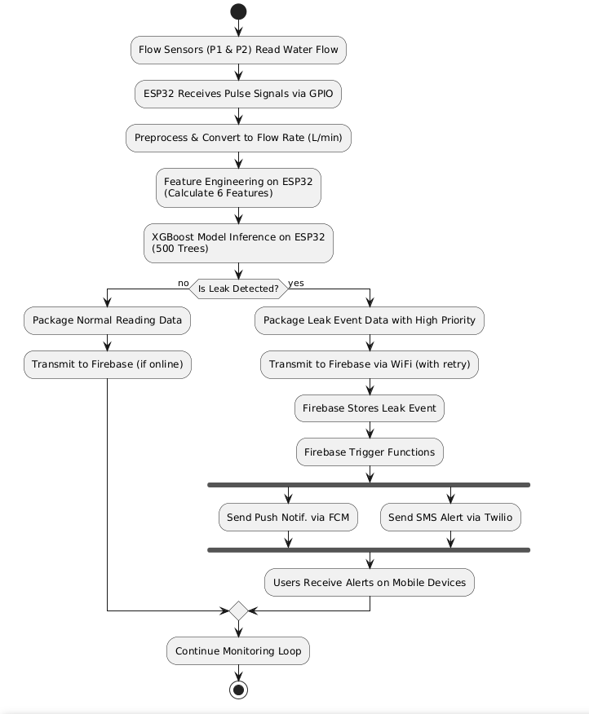
Figure 4.2 FlowWise Leak Detection Activity Diagram

Data Flow Diagram
Data Flow Diagrams (DFDs) illustrate the movement and transformation of information within the FlowWise system using external entities, processes, data stores, and data flows. The Context Diagram (Level 0) establishes the system boundary by treating the entire FlowWise platform as a single process interacting with its environment. In this high-level view, Flow Sensors provide continuous Flow Rate Data, while Consumers and Administrators submit View Requests to access specific consumption metrics. The system responds by outputting Consumption Data and Usage Reports to Consumers, alongside Analytics and System-wide Data for Administrators. When the ESP32 identifies a leak, the system generates Leak Alert Messages that flow to the Twilio SMS Gateway and Firebase Cloud Messaging service for final delivery to end users. This hierarchical DFD approach effectively manages system complexity while providing a clear overview of all external data exchanges.
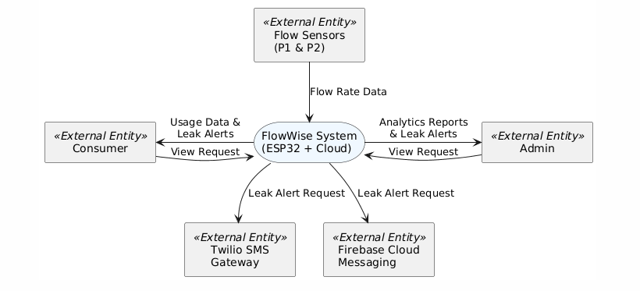
Figure 4.3 DFD level 0

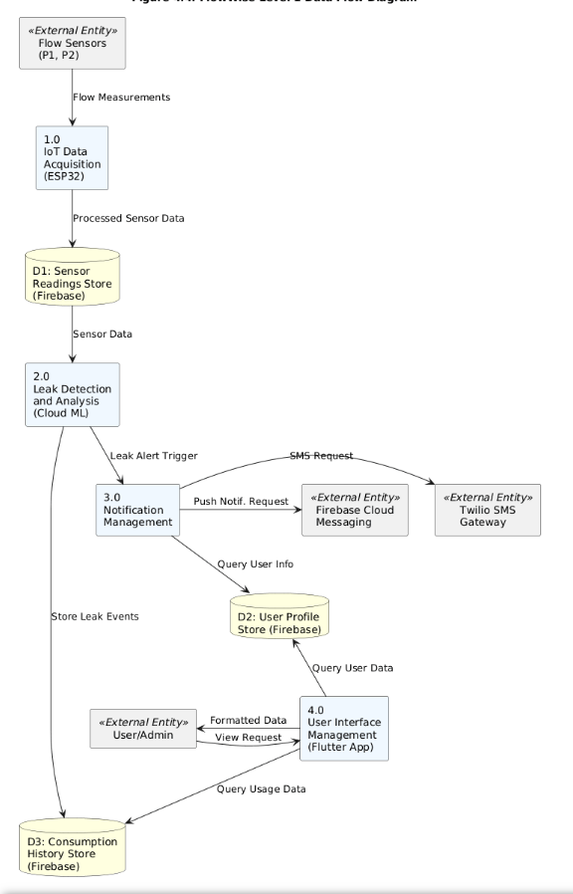
Figure 4.4 DFD level 1

System Sequence Diagram
A System Sequence Diagram (SSD) is a visual representation illustrating the sequence of messages exchanged between external actors and the system for a specific use case. For the FlowWise project, developing an SSD is essential to define the precise interface between the Consumer and the System during data retrieval. This ensures that the communication flow—from authentication to data rendering—is efficient, secure, and meets the real-time requirements of the user.
The View Water Consumption Data use case is a critical function of the FlowWise Water Leakage Detection System designed to achieve a specific User Goal. The Primary Actor is the Consumer, who initiates interactions through the mobile application to monitor their usage. These Stakeholders are primarily interested in accessing accurate historical consumption patterns and receiving timely alerts regarding potential issues.
Before this process begins, certain Pre-conditions must be met: the mobile application must be launched, and the system must be reachable via a secure HTTPS connection. The Success Guarantee for this workflow is the effective Data Visualization of consumption charts and statistics following successful user authentication.
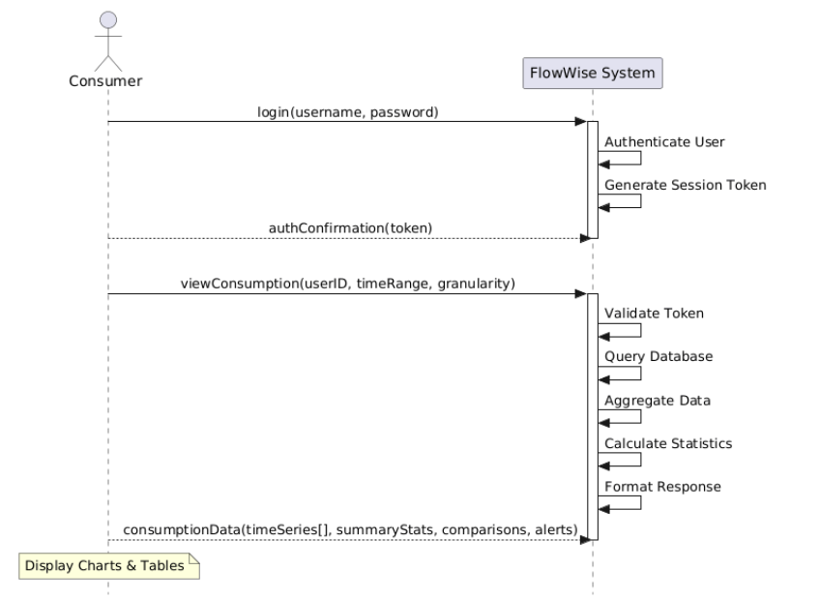
Figure 4.5 System Sequence Diagram - View Consumption

Sequence Diagram
While system sequence diagrams treat the system as a black box, detailed sequence diagrams reveal the internal component interactions that implement system behavior. These diagrams show the specific objects or components involved in a use case and the messages they exchange in temporal order. Sequence diagrams are essential for understanding complex implementations involving multiple collaborating objects, particularly in distributed systems like FlowWise where edge devices, cloud services, databases, and client applications must coordinate their actions precisely.
The detailed sequence diagram for leak detection exposes the internal architecture of the FlowWise system, illustrating the collaboration between hardware, firmware, cloud services, and machine learning models. The process begins with FlowSensors at nodes P1 and P2 generating electrical pulses proportional to flow rate, which the ESP32Controller captures via interrupt-driven GPIO pins. The controller periodically invokes methods to calculate volumetric flow rates in liters per minute and applies a moving average algorithm for noise filtering to ensure data accuracy and reduce false positives. Once preprocessed, the ESP32 constructs a JSON payload and transmits it to the FirebaseDatabase via the secure Firebase REST API.
Upon receiving new data, the CloudMLService fetches a 30-second historical window from Firebase to calculate six critical features: normalized flow values, divergence, rate of change in divergence, rolling trends, and flow volatility. These features are fed into the XGBoostModel, which utilizes an ensemble of 500 decision trees to perform majority voting. The model returns a classification result (leak or no-leak) along with a confidence score to the CloudMLService. If a leak is confirmed, the system logs a permanent record in Firebase and initiates the NotificationService.
The final stage involves the simultaneous dispatch of alerts through parallel channels to ensure reliability. The NotificationService retrieves affected user profiles and formats messages with user-friendly location details and severity levels. It then invokes the Firebase Cloud Messaging API for mobile push notifications and the Twilio REST API for SMS alerts. Finally, the MobileApp receives these notifications, updating the UI to provide consumers and administrators with immediate access to leak details.

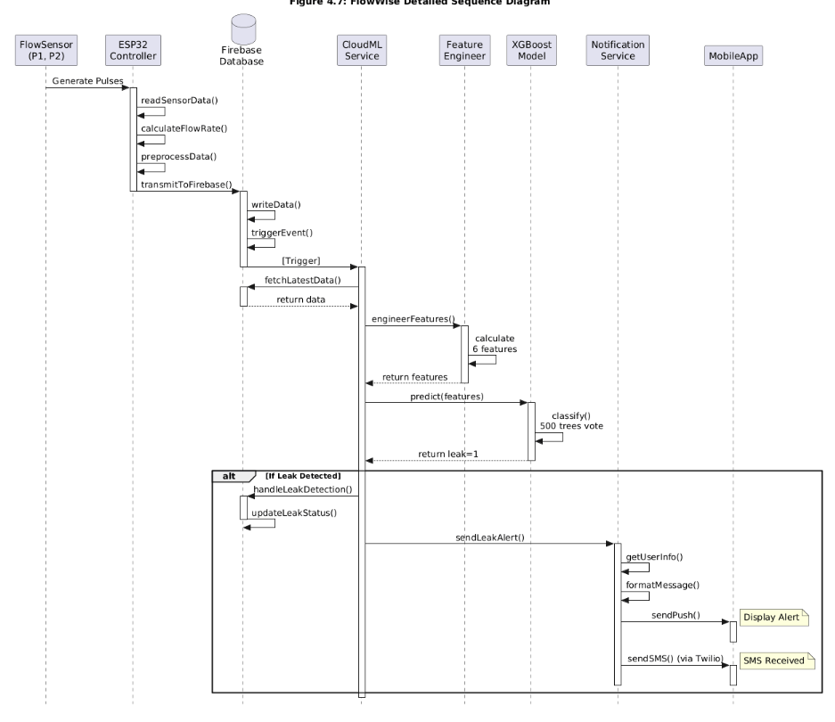
Figure 4.6: Detailed Sequence Diagram - Leak Detection

Design Class Diagram
The design class diagram represents the static structure of the software system, showing classes, their attributes, methods, and the relationships between classes. This diagram serves as a blueprint for object-oriented implementation, documenting the classes that developers must create and how they should interact. The FlowWise class diagram encompasses classes across multiple architectural layers including hardware interface, data management, business logic, machine learning, and user interface components.
Class Organization by Layers
The FlowWise system is organized into five distinct layers, each containing classes with specific responsibilities:
Layer 1: Hardware Interface Layer
Classes that directly interact with physical sensors and microcontroller hardware.
Layer 2: Local Storage Layer
Classes that manage data persistence on ESP32 flash memory for offline resilience.
Layer 3: Embedded Machine Learning Layer
Classes that implement feature engineering and XGBoost classification on the ESP32.
Layer 4: Cloud Storage Layer
Classes that provide interfaces to Firebase Realtime Database for data persistence.
Layer 5: Application Layer
Classes for notifications and mobile application user interfaces.
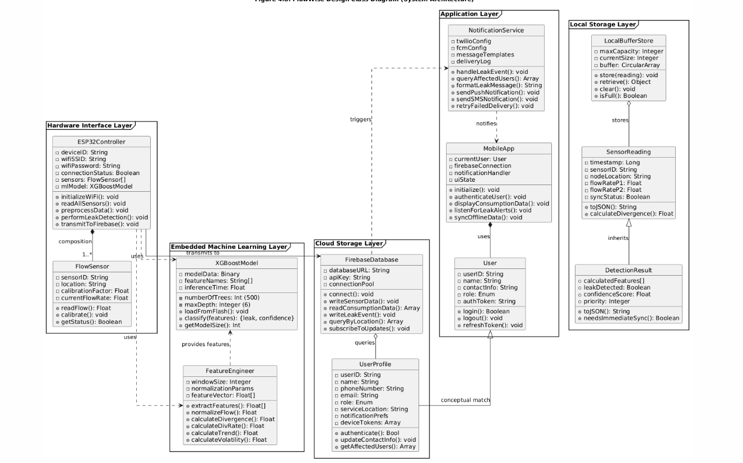
Figure 4.7: Class Diagram-FlowWise

Architectural Diagrams
Architecture serves as a blueprint for the FlowWise system, providing a necessary abstraction to manage complexity and establish clear communication mechanisms among hardware, cloud, and mobile components. For this project, we follow a distributed architecture to handle real-time IoT data processing and multi-user notifications. The following diagrams provide a diagrammatic illustration of the system's structural organization and physical distribution.

Component Level Diagrams
Choosing the Component Level Design is the most strategic decision for the FlowWise project because it provides a high-level view of how the system’s modular parts,ranging from physical sensors to cloud-based machine learning interconnect.
The component-level design represents the modular parts of the FlowWise system and their interdependence. It illustrates how the embedded controller, the analytics engine, and the notification system function as distinct yet connected units to deliver the primary user goal of leak detection.

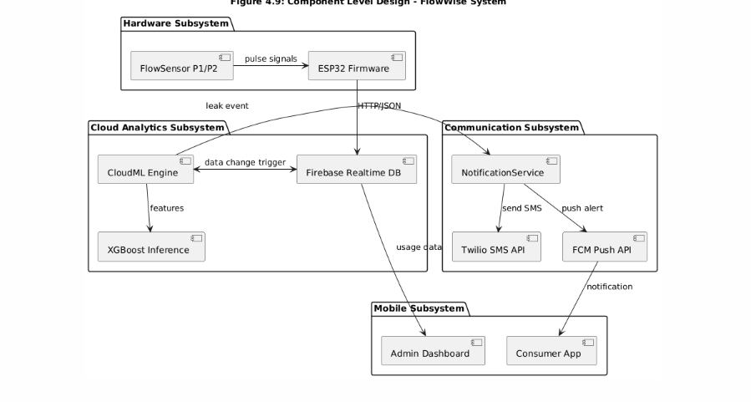
Figure 4.8:Component level Design
Component Rationale
- Hardware Subsystem: Handles the physical conversion of water flow to digital pulses and manages initial preprocessing.
- Cloud Analytics Subsystem: Acts as the "brain" of the system, triggering the ML pipeline whenever new data arrives in the database.
- Communication Subsystem: De-clutters the main logic by handling the complexities of third-party APIs like Twilio and Firebase Cloud Messaging

References

- M. A. Ayamga and C. I. Nakpih, "An IoT-based water leakage detection and localization system," Journal of Water Resources and Environmental Engineering, vol. 17, no. 3, pp. 1–14, 2024.
- M. Boujelben et al., "Acoustic leak detection and 2D localization based on non-invasive acoustic sensing and lightweight deep learning," Measurement, vol. 218, p. 113189, 2023.
- I. Bhatti, "Water crisis worsens in Karachi as supply line bursts," Dawn, Jul. 13, 2021. [Online]. Available: https://www.dawn.com/news/1634786.
- J. Gautam et al., "Monitoring and forecasting water consumption and detecting leakage using an IoT system," Water Supply, vol. 20, no. 3, pp. 1103–1113, 2020.
- N. Maqbool, "Pakistan’s urban water challenges and prospects," Pakistan Institute of Development Economics (PIDE), Knowledge Brief No. 115, 2024. [Online]. Available: https://file.pide.org.pk/pdfpideresearch/kb-115-pakistans-urban-water-challenges-and-prospects.pdf.
- "Water crisis exacerbated amid delays in pipeline repairs," The Express Tribune, Apr. 12, 2025. [Online]. Available: https://tribune.com.pk/story/2539426/water-crisis-exacerbated-amid-delays-in-pipeline-repairs.

